Methodist Church of New Zealand

Insert your logo here

zzz

xxx, Yyy

**EMERGENCY RESPONSE**

**THE FIRST PRIORITY IN AN EMERGENCY IS THE SAFETY OF ALL PEOPLE PRESENT**

* Raise the alarm.
* Turn to the relevant page to confirm what to do.

|  |  |
| --- | --- |
| **During office hours** | [Name of Office Hours Contact Person]  {phone} |
| **Weekday Wardens** | [Name of chief Warden]  [Name of warden] |
| **Sunday Wardens** | Stewards of the Day  Names on rosters on notice board in church foyer |
| **First Aiders** | [Name of first aider]  [Name of first aider] |
| **After office hours** | [Name of ] (for the alarm)[Name of ]  {phone}{phone}  [Name of ][Name of ]  {phone}{phone} |
| **Report Incidents to:** | [Parish Superintendent]  {phone} |

**In case of a major incident phone 111**

To be effective, this plan must be read and understood by everyone until it becomes second nature!

Emergency Procedures Guidelines

|  |  |
| --- | --- |
| **Key items’ locations** | Gas shut off:   * + [Clear instructions to let others find the location easily, or use “No gas on site”]   Main Fuse Box:   * + [Clear instructions to let others find the location easily and quickly]   Main water toby:   * + [Clear instructions to let others find the location easily and quickly]   Gas/oxygen cylinders:   * + [Clear instructions to let others find the location easily, or use “No cylinders on site”]   Fire Alarm panel   * + [Clear instructions to let others find the location easily, or use “No fire alarm panel on site”] |
| **Emergency Contacts**  Remember Dial 111 for immediate Fire, Police and Ambulance requirements. | [Name] Police Station  [Street Address, Town]  {phone}  [Name] Fire Station  [Street Address, Town]  {phone}  [Name] Medical  [Street Address, Town]  {phone}  [Name] Hospital  [Street Address, Town]  {phone}  Poisons Centre  0800 764 766 |
| **Neighbours** | [Name of neighbour]  [Street Address, Town]  {phone}  [Name of neighbour]  [Street Address, Town]  {phone} |

**Emergency Procedures Guidelines…**

|  |  |
| --- | --- |
| **Contractors and Consultants** | Builder  [Company name – contact name]  {phone}  Cleaner  [Company name – contact name]  {phone}  Security  [Company name – contact name]  {phone}  Plumber  [Company name – contact name]  {phone}  Air Con  [Company name – contact name]  {phone}  Electrician  [Company name – contact name]  {phone} |

**POWER FAILURE**

*If a general power supply failure occurs:*

|  |  |
| --- | --- |
| **Remain calm** | Assist visitors and staff in your area |
| **If you are in an unlit area** | * Use the light on your cellphone if you have one, or, * Wait for the Wardens who will move through all unlit spaces with flashlights * Wardens will escort people to safety * Remember these instructions as you will have difficulty reading them in the dark! * All exit doors have an emergency light above the door |
| **If you are stuck in an elevator** | * Stay calm * Use the emergency telephone to notify the operator * Phone the [name] if you are able   {phone} |
| **Wait for Wardens instructions** | * Wardens will evaluate the risk at the time * If asked to evacuate, proceed to designated Assembly Area |
| **Look after people first** | * Leave the Wardens to secure the building |

**EXPLOSIONS**

*If there is an explosion*

|  |  |
| --- | --- |
| **Remain calm and alert** | * Remain calm and be prepared for more explosions * Avoid areas where objects may fall on you (eg windows, mirrors, overhead fixtures, filing cabinets, bookcases) * Be guided by Wardens or emergency services personnel |
| **If evacuation is declared** | * Be guided by Wardens or emergency services personnel * When evacuating, leave doors and windows open |
| **If someone is injured** | * Don’t move injured people unnecessarily * Inform your Wardens * Reassure the person, help is on the way * Render first aid only if you are trained to do so |
| **Remember!** | * Open doors carefully * Watch for falling objects * Do not use lifts * Do not use matches or lighters * Keep telephone lines free |
| **Be aware of possible causes** | * Bombs * Flammable/explosive objects * Chemical accidents * Leaking gas * Motor vehicles |

**EARTHQUAKE**

*If there is an earthquake:*

|  |  |
| --- | --- |
| **During** | * Take cover [name the safest place to take cover – under structural beams, tables and away from glass] * Beware of falling objects * Stay away from windows, and possible breaking glass * Remain where you are until tremors have ceased |
| **After** | * Remain where you are until the risk of further tremors or danger from falling objects has ceased * Make verbal contact with others to identify the severity of the situation * Follow the instructions of the Wardens |
| **If someone is injured** | * Don’t move injured people unnecessarily * Inform your Wardens * Reassure the person, help is on the way * Render first aid only if you are trained to do so |
| **Evacuation** | * Follow the instructions of the Wardens * DO NOT RUN FROM THE BUILDING |
| **Remember!** | * Look after your own safety first * Life comes before property * Keep telephone lines free * Avoid ‘live’ electricity: hanging cables, light fittings, or any metal objects or water that might be in contact with loose wires |

**DISRUPTIVE VISITORS / UNWANTED BEHAVIOUR**

*If a visitor shouldn’t be here, or their behaviour is causing concern:*

|  |  |
| --- | --- |
| **Give yourself an escape route** | * Keep moving if you have to * Don’t let them block your exit path |
| **Keep clear of them** | * Keep cool * Don’t put yourself or others in harm’s way. * Keep at least 2m between you and them |
| **Keep calm** | * Breath! |
| **Distract them so you can leave** | * Offer to fetch them tea, water, coffee * Offer to fetch [suitable person in your building] to help |
| **Tell Others**  Remember!  Dial 111 if you can or tell someone else so they can! | * You don’t have to handle this by yourself * Use   + Email   + Text   + Telephone: Dial 111   + Yell |
| **If they are outside** | * Shut down building access * Lower all blinds/curtains * Stand back from windows |

**BOMB THREATS AND SUSPICIOUS OBJECTS**

*If there is a telephone threat:*

|  |  |
| --- | --- |
| **Listen Carefully** | * Remain calm, be polite and show interest, try to keep the caller talking * Gather information * Refer to the bomb threat checklist (next page) |
| **Get help** | * Pass a note to get someone else to help you |
| **When the call ends** | * Inform [Parish Superintendent]   {phone}   * [Parish Superintendent] will contact the police * Write out a bomb threat report (all the details that you can remember) * Control any panic * Evacuate the building if instructed |

*If there is a suspicious parcel or object:*

|  |  |
| --- | --- |
| **Keep away** | * Remain calm * Keep everyone away |
| **Tell Office Reception** | * Inform [Parish Superintendent]   {phone}   * [Parish Superintendent] will contact the police |
| **Gather information** | * Write down all details for the Police to use |
| **Keep calm** | * Control any panic * Inform the [Parish Superintendent]to deal with the situation * Evacuate the building if instructed |

**BOMB THREAT CHECKLIST**

|  |  |
| --- | --- |
| **Keep Calm**  **Don’t hang up!** | * Write down the threat * Note the exact wording |
| **Ask the caller these questions** | 1. When will the bomb explode? 2. What does the bomb look like? 3. What kind of bomb is it? 4. What will make the bomb explode? 5. Did you place the bomb? 6. Where did you put the bomb? 7. Are you familiar with the area? 8. Why did you place the bomb? 9. What is your name? 10. Where are you, what is the address? |
| **Pay attention to caller’s voice** | * Accent (specify) – well spoken? * Male? Female? Age? * Any impediment (specify) – incoherent? * Voice (loud, soft) – irrational? * Speech (fast, slow) – taped? * Diction (clear, muffled) – message read by caller? * Manner (calm, emotional) – abusive? * Do you recognise the voice? * If so, who do you think it is? |
| **Note any background noises** | * Street or house noises * Aircraft * Voices/Music * Machinery * Local call/cell phone |
| **General Information** | * Date * Time * Call length * Caller display details |

**First Aid ReSponse**

*What to do if a person is ill or injured:*

|  |  |
| --- | --- |
| **Avoid moving the person** | Don’t move the person unnecessarily unless the situation is life threatening |
| **Inform the a Warden** | * A Warden will arrange first aid assistance |
| **Wait with the person** | * Reassure the person, help is on the way * Render first aid only if you are trained to do so |
| **Give help and information** | * Find out the person’s name * Help to take care of their needs |
| **After the person is well cared for** | * Inform the [Parish Superintendent] * Ensure an accident report is completed |

*Bleeding Wounds*

|  |  |
| --- | --- |
| **Control the bleeding** | * Apply direct pressure to wound – use your hand(s) (wear gloves) * Elevate (raise) the limb * Apply a pad and firm bandage * If necessary use clean rags or clothing |
| **Remember** | * Always check circulation below the bandage * If there is tingling, numbness or blues, loosen the bandage |

*Breathing difficulties*

|  |  |
| --- | --- |
| **Unconscious but breathing** | * Turn them onto their side * Clear airway of obstructions, such as tongue or vomit |
| **Remember** | * Seek medical help, if necessary |

**First Aid Response…**

*Burn Management*

|  |  |
| --- | --- |
| **Cool the burn** | * Cool under cool running water for 10-15 minutes |
| **Cover the wound** | * If necessary, cover the burn with a clean dressing or plastic wrap before removing the person to medical aid |
| **Remember** | * Leave any blisters alone * Leave stuck clothing alone * Do not apply creams |

*Eyes - Foreign bodies*

|  |  |
| --- | --- |
| **Wash the eyes** | * Wash the eye(s) with clean clear water |
| **If washing doesn’t work** | * If the foreign body is stuck to the eye surface, DO NOT attempt to remove it * Place a covering over both eyes and send for, or take the person to, medical aid |

*Poisoning*

|  |  |
| --- | --- |
| **Seek help!** | * Seek medical advice * Call an ambulance |
| **Remember** | * Do not make the person vomit without advice from a medical professional * Do not give fluids without advice from a medical professional * Have somebody find the Safety Data Sheet for the poison if it is held on site. |

*Wounds - minor*

|  |  |
| --- | --- |
| **Clean the wound** | * With soap and water |
| **Cover the wound** | * Cover lightly with clean dressing |
| **Remember** | * Seek medical help if necessary |

**First Aid Response…**

*CPR – Cardio-pulmonary resuscitation in summary*

|  |  |
| --- | --- |
| **When to do CPR** | * Patient has collapsed * Is non-responsive * Is not breathing normally |
| **Assess carefully** | * Carefully decide what emergency care is needed * Chest compressions are the most important part of CPR * If you cannot give breaths, then DO chest compressions |
| **Danger** | * Check for the safety of yourself, the casualty and bystanders |
| **Response?** | * Check for a response:   + Tap the person   + Gently shake and shout |
| **Send for help** | * Phone 111 and ask for an ambulance |
| **Airway** | * Open the airway * Tilt head back |
| **Breathing and CPR** | * If not breathing normally, start CPR   + 30 chest compressions   + Two breaths |
| **Defibrillate** | * If you have been trained in its use and have a defibrillator,   + Attach an AED   + Follow the machine prompts |

*CPR Trained First Aiders*

|  |  |
| --- | --- |
| **First Aiders** | * [Name of first aider] * [Name of first aider] |

*Medical Centre*

|  |  |
| --- | --- |
| **Closest Emergency Centre** | * [Name of closest emergency centre] [Street address, town] {phone} * Or dial 111 and ask for an ambulance |

**First Aid Response…**

*CPR – Cardio-pulmonary resuscitation in detail*

|  |  |
| --- | --- |
| **Arrange the patient’s head** | * Tilt head back * Raise chin forward * Check for normal breathing |
| **Check for normal breathing** | * Look for movement * Listen for breathing * Feel for breath on your cheek * If casualty is not breathing normally, turn on back, start CPR |
| **Chest compressions** | * Position hands in centre of chest, push down firmly and quickly 30 times |
| **Poison suspected?** | * Make sure there is no residual poison in the mouth * Consider mouth to nose resuscitation |
| **Breathing** | * Tilt head * Pinch nose * Seal your mouth over patient’s mouth * Blow twice into patient’s mouth |
| **While waiting for help to arrive** | * Repeat   + 30 chest compressions   + 2 breaths |
| **Reluctant to give mouth to mouth** | * Continue with chest compressions * Chest compressions are the most important part of CPR |

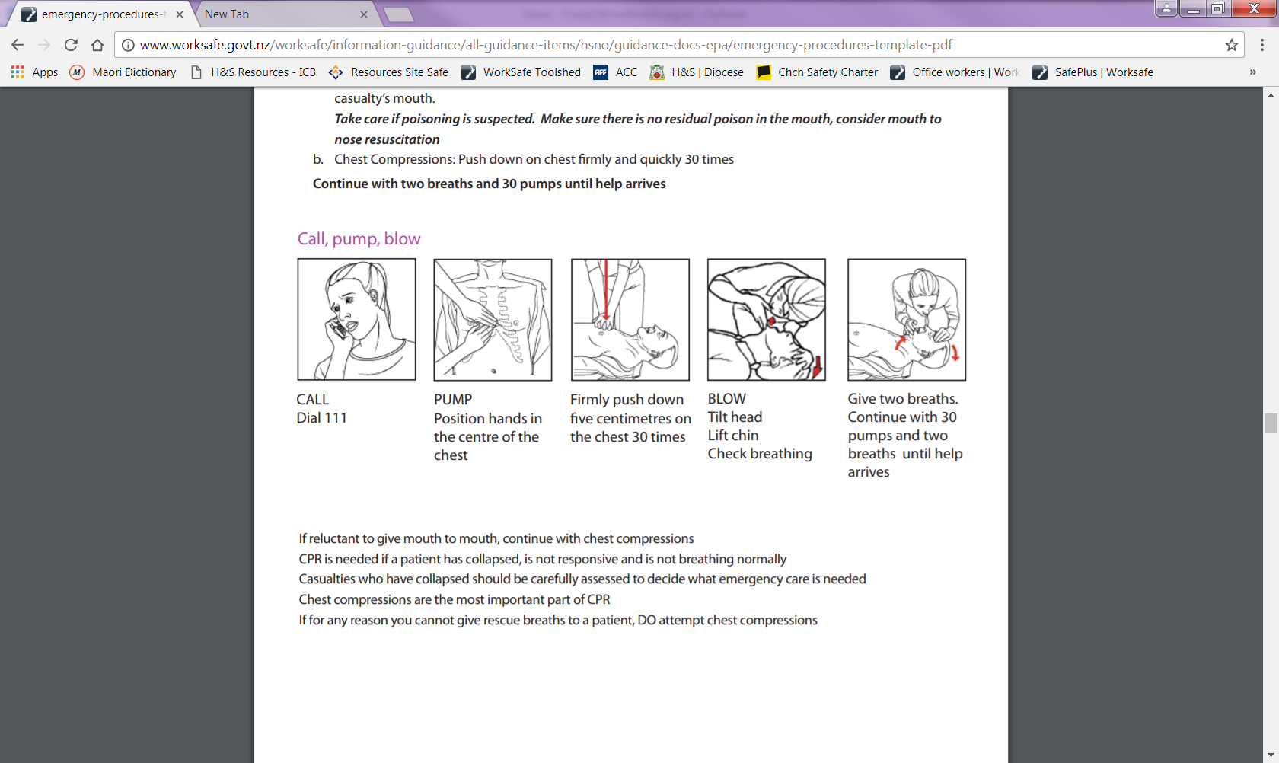

**FIRE**

*If there is a fire:*

|  |  |
| --- | --- |
| **Raise the alarm** | * Remain calm * Activate nearest fire alarm by nearest building exit * Or commence a manual warning (whistle, shout etc) and then activate nearest fire alarm * **Ring 111** * Automatic detectors may also trigger the alarm |
| **When the alarm is raised** | * Evacuate the building * Proceed to the Assembly Area in the Rear Carpark |
| **Exit the building** | * Only use stairs, not the lift * Close the doors * *CLOSED DOORS INDICATE THE ROOM IS CLEAR* * Only return to the building when advised by Fire and Emergency NZ/ Wardens |

*Useful things to know:*

|  |  |
| --- | --- |
| **Escape route** | * Know the evacuation plan! |
| **Confining fire** | * Oxygen feeds fires * Close doors, do not open windows |
| **Hot or smoking doors** | * Do not open hot or smoking doors * Before opening any door, touch it near the top with the back of your hand to test for heat. * If door is hot or smoke is visible, do NOT open the door |
| **Very small fire?** | * If you are trained and confident, use the fire extinguisher * Use the fire extinguisher if it is deemed safe to do so * Report the fire to the Wardens |
| **Report all fires** | * Tell the Wardens |

**Fire…**

|  |  |
| --- | --- |
| **Using a fire extinguisher** | * Always ensure your escape path is clear of fire and obstacles (change your escape path if necessary) * Make sure the extinguisher is of the correct type * Make the extinguisher ready for use by breaking the seal/removing the safety pin * Carry the extinguisher to the fire * Keep yourself low to reduce the effect of heat and smoke * When in position, aim the extinguisher in a sweeping motion across the base of the flames * Keep going until you have completely extinguished the fire * If the fire becomes uncontrollable, or there is too much heat or smoke for safety, LEAVE IMMEDIATELY |
| **After the event** | * Complete an incident report * Inform the [Parish Superintendent] * Review the effectiveness of the emergency plan |

**xxx, yyy – Fire Alarms and Fire Extinguishers**

**Carpark**

3 x Fire Alarms by all exits

3 x Extinguishers (Staff Room, reception, server room)

1 x First Aid kit (Staff Room)

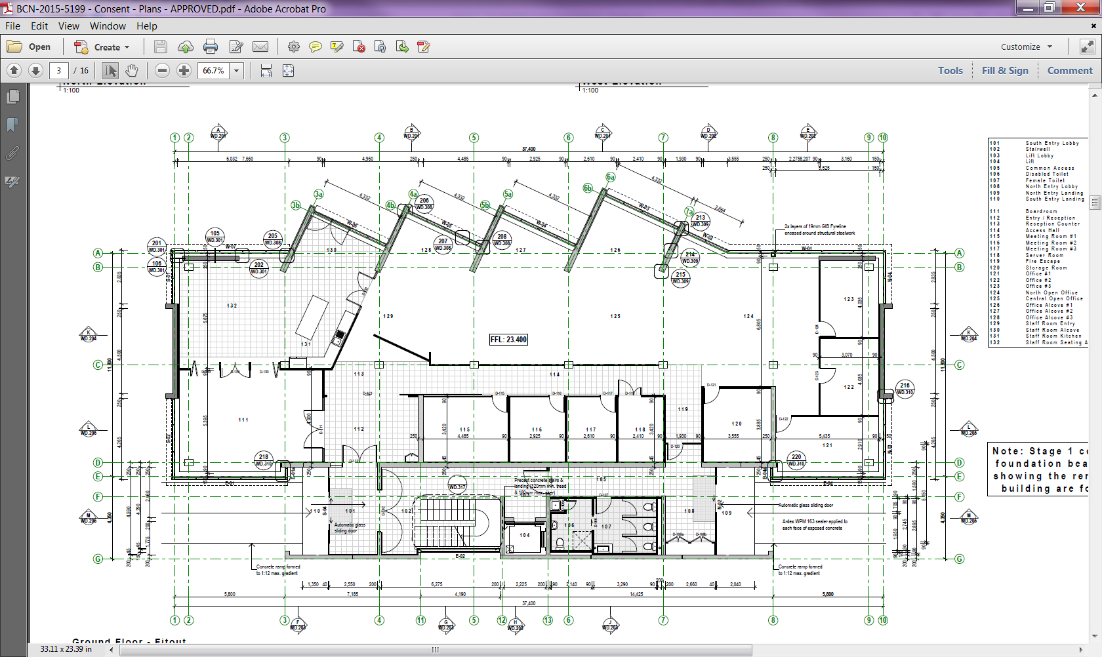

**Langdons Road**

**Ext** - Extinguishers

**F** - Fire Alarm

**+** - First Aid Kit

**AED** - Defibrillator

**+**

**F**

**F**

**Ext**

**Ext**

**Ext**

**F**

**EVACUATION PLAN**

|  |  |
| --- | --- |
| **Be prepared** | * Recognise the sound of the evacuation alarm * Know at least two ways out of the building from your regular area * Know where your nearest fire alarm and exit are * Let your Wardens know if you are will require evacuation assistance. A “Personal Emergency Evacuation Plan” will be agreed with you. |
| **Know the alarm sound** | * Is a [continuously ringing bell, a continuous warning siren etc.] throughout the building |
| **When you hear the evacuation alarm** | * Remain calm * Be hands free and distraction free when you exit the building   + Phones and keys in your pockets   + handbag closed (avoid spillages) and securely hooked on your shoulder (handsfree!)   + Leave food and drink behind * Leave quickly through the nearest exit of the building * Listen to the wardens |
| **Escape routes** | * [Ground Floor   + Main entry doors – facing Langdon Road. Proceed around to the rear carpark assembly area   + The rear door leading to the rear carpark assembly area * First Floor   + Use the stairs   + DO NOT USE THE LIFT] |
| **After hours** | * Wardens may not be present * You must call 111 * You must attend to the emergency response services when they arrive on site * You must ensure, as far as safely possible, that   + all building occupants have left the building   + documented processes are followed |
| **Instances beyond the normal arrangements** | * Such as working along, late openings, events * What alternative measures would be needed * Do you need the “Hireage evacuation plan”? |

**Evacuation Plan…**

**xxx, yyy – Assembly Point**

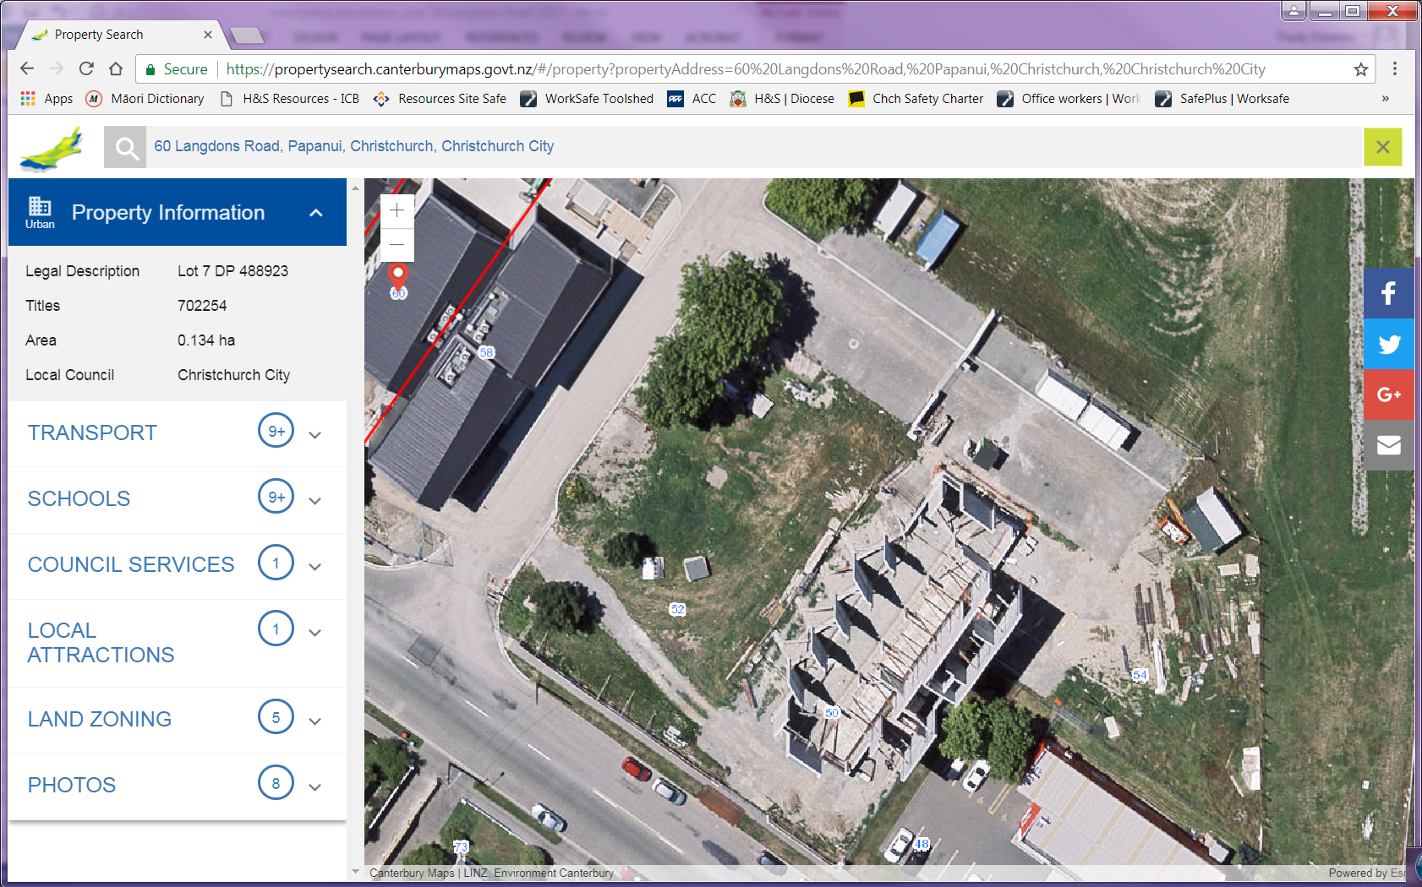

Assembly Point

**Evacuation Plan…**

|  |  |
| --- | --- |
| **As you are leaving** | * Check that others in the building are also leaving, including researchers * Exit with your hands free of “stuff” * You may take your car keys and purse * Do not take large or heavy objects * Assist anyone who may be in need of calm direction, or physical assistance * Shut all doors behind you as you go (closed doors slow the spread of fire, smoke and water) * Proceed as quickly as possible in an orderly manner, without pushing or shoving * Hold handrails when you are walking if you are on stairs |
| **Doors** | * Fire Evacuation   + Shut the doors – deprive the fire of air * Explosion Evacuation   + Leave the doors (and windows if any) open! |
| **Know the Assembly Point** | * [describe where the assembly point is so it can be clearly and easily found] |
| **Once out of the building** | * Move away from the structure * Proceed to the Assembly Area * Meet and remain in the Assembly Area * Be patient while heads are counted * Wait for further instructions from the Wardens |
| **Obey the Wardens** | * The Warden present in each area is responsible for ensuring everyone in their area evacuates * Please assist by following the Warden’s instructions |

**Evacuation Plan…**

**xxx, yyy – Services**

**E** – Electrical Board

**BBQ** – 9kg BBQ cylinder

**CO2** – Fizzy Water

**F**– Fire Board

**H2O** – Water Toby

**BBQ**

In shed in fenced patio



**H2O**

Green box front LHS (face building) of carpark

**CO2**

**E**

**F**

**EMERGENCY TEAM**

**Wardens**

|  |  |
| --- | --- |
| **Wardens** | Wardens 1  **[Name]**  Wardens 2  **[Name]**  Wardens 3  **[Name]** |
| **Equipment** | * Identification [vest/sash] * Flashlight * Mobile phones * Personal Emergency Evacuation Plans * Door tags (optional) to show checked rooms) |
| **Qualifications** | * [Normally in the building between 8.30am and 5pm Mon-Fri. * Arrange a back up arrangement for prolonged absences.] |
| **Power failure** | * Escort people to safety from the unlit areas (toilets, stairwells) * Co-ordinate with other wardens that everyone is accounted for * Evaluate/evacuate if the building is unsafe * Secure the building |
| **Explosions** | * You will be the contact point should someone be injured * Co-ordinate with the first aider or emergency services if there are injured persons * Evaluate the building risk * Evacuate the building if outside is safer than in * Co-ordinate with other wardens that everyone is accounted for |
| **Earthquake** | * Evaluate the risk * Evacuate the building if necessary |

**Wardens…**

|  |  |
| --- | --- |
| **Evacuations** | * Sweep designated areas to ensure people are clear of the rooms – *if it is safe to do so.* * Keep yourself safe * Evacuate where you can and inform the Chief Warden if you couldn’t evacuate areas or people   **Warden 1:**   * + [clearly detail the sweep area]   + Dial 111   + Take reports from other wardens   + Coordinate building clearance and emergency services   + Co-ordinate the 111 response and delegate someone to direct 111 services to the building   **Warden 2:**   * + [clearly detail the sweep area]   + Turn off power if it is safe to do so.   + Confirm building clearance with Warden 1   + Wait for emergency response and direct them to Warden 1   + Help keep everyone at the assembly area   **Warden 3:**   * + [clearly detail the sweep area]   + Confirm building clearance with Warden 1   + Help keep everyone at the assembly area |

**Wardens sweep areas**

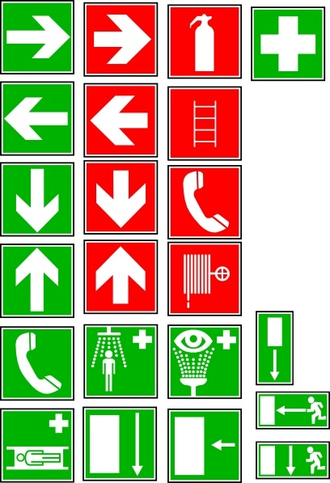**\*\***

**Building Warden**

Alarm Panel

**Warden 3**

Ground floor

**Warden 1**

Ground floor

**Warden 2**

First floor & toilets

Turn page…

**Parish Superintendent**

|  |  |
| --- | --- |
| **Equipment** | * Contact list * Telephone (cordless/mobile) |
| **During office hours** | * You are the central contact person * Staff and visitors should inform you if they will require evacuation assistance so that a Personal Emergency Evacuation Plan can be agreed. |
| **During church services** | * You are the central contact person * Parishioners should inform you if they will require evacuation assistance so that a Personal Emergency Evacuation Plan can be agreed. |
| **Illness and injury** | * Get the first aider to the ill/injured person * If required, help co-ordinate the 111 response |
| **Power Failure** | * Co-ordinate with Wardens that everyone is accounted for * [Anyone stuck in the elevator may call you] |
| **Disruptive visitors** | * Tell someone! * Email, text, telephone, buzz the buzzer! * Safety in numbers – get backup! * Leave the area and go find other people |
| **Bomb Threats and Suspicious Objects** | * Contact the police |
| **Evacuations** | * Grab the visitor registration book and evacuate the building with everyone else * Co-ordinate with Wardens that everyone is accounted for |
| **Reporting** | * Report all incidents to the Synod |

**Parish Superintendent…**

|  |  |
| --- | --- |
| **Dialling 111** | * Call from a safe place * Use a cordless or mobile phone * Give your   + Your name   + Name of the building – **zzz**   + Building address – **xxx, yyy.**   + Contact number – **{phone}** ***and an appropriate mobile number***   + Details of emergency – ***if known*** * Do not hang up until told to do so * Ensure someone is available to direct emergency services to the scene |

**First Aiders**

|  |  |
| --- | --- |
| **Equipment** | * First Aid Kit |
| **Qualification** | * Normally in the building between 8.30am and 5pm Mon-Fri. * Arrange a back up arrangement for prolonged staff absence. * Holder of a current, approved, first aid certificate * Current medical practitioner |
| **First Aiders** | **[name] –** *[Certification status/expiry date]*  **[Name] –** *[Certification status/expiry date]* |
| **Illness and injury** | * You will be in charge unless/until 111 response is present |
| **Explosions / Earthquakes / Fire** | * Co-ordinate with Wardens if there are injured people |
| **111 services** | * Coordinate with Reception and Wardens so someone directs 111 services to the injured person |

**Emergency Planners**

|  |  |
| --- | --- |
| **Author** | [Names] |
| **Emergency staffing** | [Parish] |
| **Back up staffing** | Raised by person going on leave  Agreed at [parish] meetings |
| **Training staff on the plans** | [Parish Superintendent] |
| **Plan Dates** | Draft written [date]  Out to review [date]  Approved [date] |
| **Review plan** | 6 monthly |