METHODIST MISSION AND ECUMENICAL NEWSLETTER - April 2022

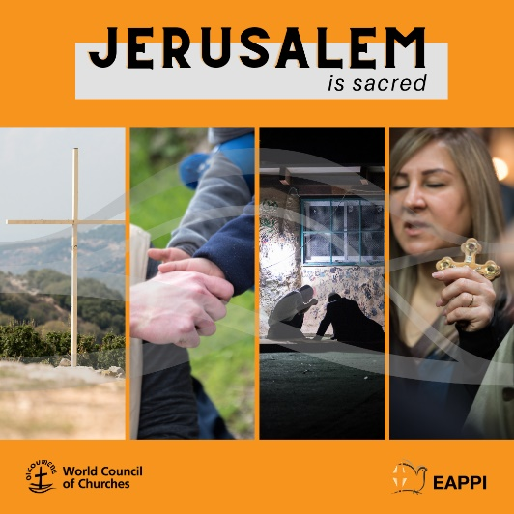
ECUMENICAL ACCOMPANIMENT PROGRAMME IN PALESTINE AND ISRAEL (EAPPI): Easter Initiative 2022
Jerusalem is sacred to Christians, Muslims and Jews. During high holidays like Easter, the holy month of Ramadan and Pessach, all of which overlap in 2022, this sacredness can be felt by locals and visitors alike. But the sacredness of the Holy City and its inhabitants is increasingly threatened by consequences of the ongoing occupation, such as discrimination and violence.
In December 2021, the Heads of Churches in Jerusalem issued a strong statement urging the international community to take up meaningful action to advocate for a Jerusalem without violence and intimidation, and for the preservation of the multi-faith identity of Jerusalem.
Through this year’s Easter Initiative, the World Council of Churches EAPPI seeks to connect the sacredness of Jerusalem with what is sacred to us as human beings: home, family, worship, identity, human dignity and life, and solidarity. The Easter Initiative takes a look at how the sacredness of Jerusalem and its inhabitants is threatened today, shedding light on human rights violations that occur in Jerusalem and that are detrimental to the character of Jerusalem as the City of Peace for people of different religious and national backgrounds. The programme also highlights the steadfastness of people living in the city and lift up initiatives that invite people to stand in solidarity with those suffering from violence, intimidation and the prolonged occupation.
Pray and act for the peace of Jerusalem: The sacred ground of Jerusalem should be protected for all people sharing the city, irrespective of religious or national identity. WCC’s calls on church leaders and elected representatives worldwide to pray for the peace of Jerusalem, to take meaningful action to stop forced displacement, violence and intimidation in Jerusalem, and to support work towards an end to the occupation and a just peace for all people in Palestine and Israel.
A variety of resources including Bible studies, news and reflections, can be found at: https://www.oikoumene.org/what-we-do/eappi/easter-initiative-2022
ECUMENICAL EASTER DAY SERVICE FOR RADIO NEW ZEALAND
Following the ecumenical service recorded in Wellington for Christmas Day 2021, for Easter 2022 a special recording of a service has been made in Auckland. It will be broadcast on Radio New Zealand National programme at 7:10am and 11:00pm; and on Concert Programme at 9:05am.
An international flavour was added to the ecumenical mix with 10 languages used; and the ecumenical diversity including Ukraine Orthodox, Armenian Apostolic Orthodox, Syrian Orthodox, Melkite Catholic - as well as Anglican, Methodist and Roman Catholic.
WEEK OF PRAYER FOR CHRISTIAN UNITY – 29 May to 5 June
The southern hemisphere observance of the Week of Prayer for Christian Unity is in between Ascension and Pentecost. This year the official observance will be 29 May to 5 June for 2022.
The 2022 theme is “We saw the star in the East, and came to worship him”; prepared by Middle East Council of Churches based in Beirut, Lebanon. Though the text for this year’s theme is commonly associated with Epiphany at the beginning of the liturgical year, For Aotearoa-New Zealand, there is the opportunity to contextualise this with the observance of Matariki – and the appearance of these stars in our skies.
If you are planning ahead for local ecumenical services, or looking to incorporate the theme into your Sunday parish worship, The international resources are available at:
https://www.oikoumene.org/events/week-of-prayer-for-christian-unity
CHRISTIAN CONFERENCE OF ASIA CONSULTATIONS – gender and HIV-AIDS, and the impact of COVID-19 on human trafficking
Two online consultations were recently hosted and organised by CCA.
One was on the theme 'Towards an Effective Advocacy on HIV and AIDS for Upholding Dignity of Gender and Sexual Minorities' which was held virtually from 24 to 25 March 2022. The Asia region is home to an estimated 5.8 million people living with HIV in 2019 (UNAIDS Report, 2020). Structural factors, such as stigma, discrimination and violence based on sexual orientation and gender identity and the criminalization of same-sex sexual practices, contribute to hindering the availability, access, and uptake of HIV prevention, testing and treatment services among gay men and other men who have sex with men. Removing discrimination and prejudice against vulnerable groups and thereby ensuring that the widest possible information regarding safe sex practices, health services and HIV prevention and treatment measures is accessible to the people who need it most.
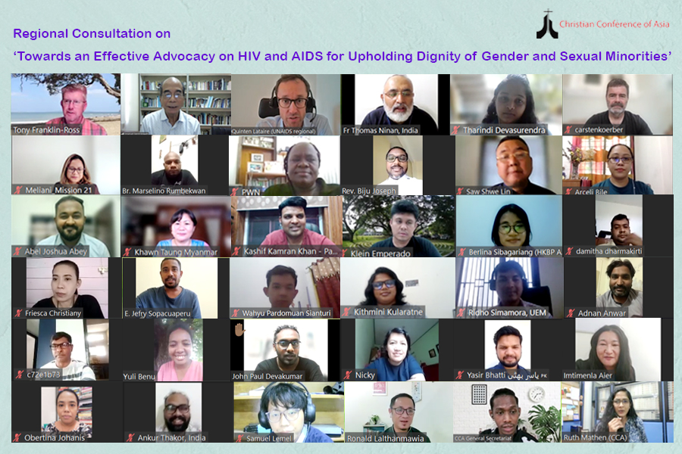
About 31 participants from different countries across Asia and beyond attended the online consultation. The participants emphasised on the importance of addressing human sexuality in a comprehensive manner to have effective HIV programmes in churches. The five presenters and resource people for the consultation included Rev Tony Franklin-Ross; who spoke on the issues of gender, toxic masculinity, ‘texts of terror’ in relation to gender based violence, and Gender-transformative approaches within the HIV response, focusing on Gender Dimensions in HIV programming.
Further information can be found at: https://www.cca.org.hk/news-and-events/upholding-dignity-of-gender-and-sexual-minorities-must-be-priority-when-designing-hiv-and-aids-programmes-within-churches/
The second, ‘Effects of COVID-19 on Trafficking in Persons’ was held on 29–30 March 2022. The online Consultation, which was attended by over thirty participants from across Asia, focused on issues such as the gendered nature of trafficking in Asia, the situation of labour trafficking, and the importance of comprehensive prevention and response strategies. The Consultation also offered a platform for the participants and resource persons to share innovations, best practices, and strategies of resilience and adaptation in ongoing anti-trafficking ministries amidst the COVID-19 pandemic.
Dr Mathews George Chunakara, the General Secretary of the CCA, highlighted the ways in which the COVID-19 pandemic had worsened human flows and migration, pushing people into vulnerability and into risk of being trafficked: “Human trafficking has been identified as the fastest growing criminal activity in the world today. The magnitude of this heinous crime is difficult to quantify and is often underestimated given its insidious and complex nature, which is only made worse by the COVID-19 pandemic.”
Further information can be found at: https://www.cca.org.hk/news-and-events/effects-of-covid-19-on-trafficking-in-persons-was-focus-of-ccas-regional-consultation/
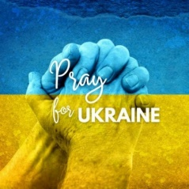
UKRAINE: world-wide ecumenical prayer and concern
Loving God, your Son Jesus Christ, wept over Jerusalem.
Today, we weep over Ukraine.
We weep for those uprooted from their homes and lives.
We weep for those cowering in basements.
We weep for those who have witnessed death and destruction on their streets.
We weep for those separated from parents, from children, from spouses and siblings.
We are amazed at the resilience of people seeking to comfort those in need and so we pray for Governments opening up borders so that Ukrainians can have safe passage.
We pray for churches and individuals providing food, clothing and shelter.
We pray for medical workers ensuring that shattered bodies are put back together again.
We pray for ordinary Russians demonstrating and voicing their disapproval of the military actions in Ukraine.
May the Holy Spirit give us the willpower to turn our tears into action also.
May we, through our words, prayers and example pursue the things that make for a just peace in the world today and especially in Ukraine.
In the name of Jesus Christ, we pray. Amen. (Methodist Church of Britain)
MISSION AND ECUMENICAL BOARD
Methodist Church of New Zealand
Te Hāhi Weteriana o Aotearoa
[Acting] Director: Rev. Tony Franklin-Ross
Postal: 20a Georgina Street, Freemans Bay, Auckland 1011
Phone: 021-481 816 (Mobile)
E-mail: mm-e@methodist.org.nz
www.methodist.org.nz/mission_and_ecumenical

