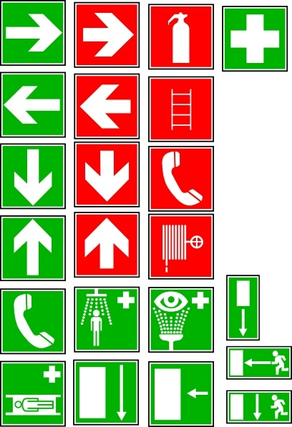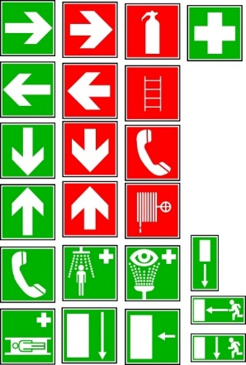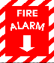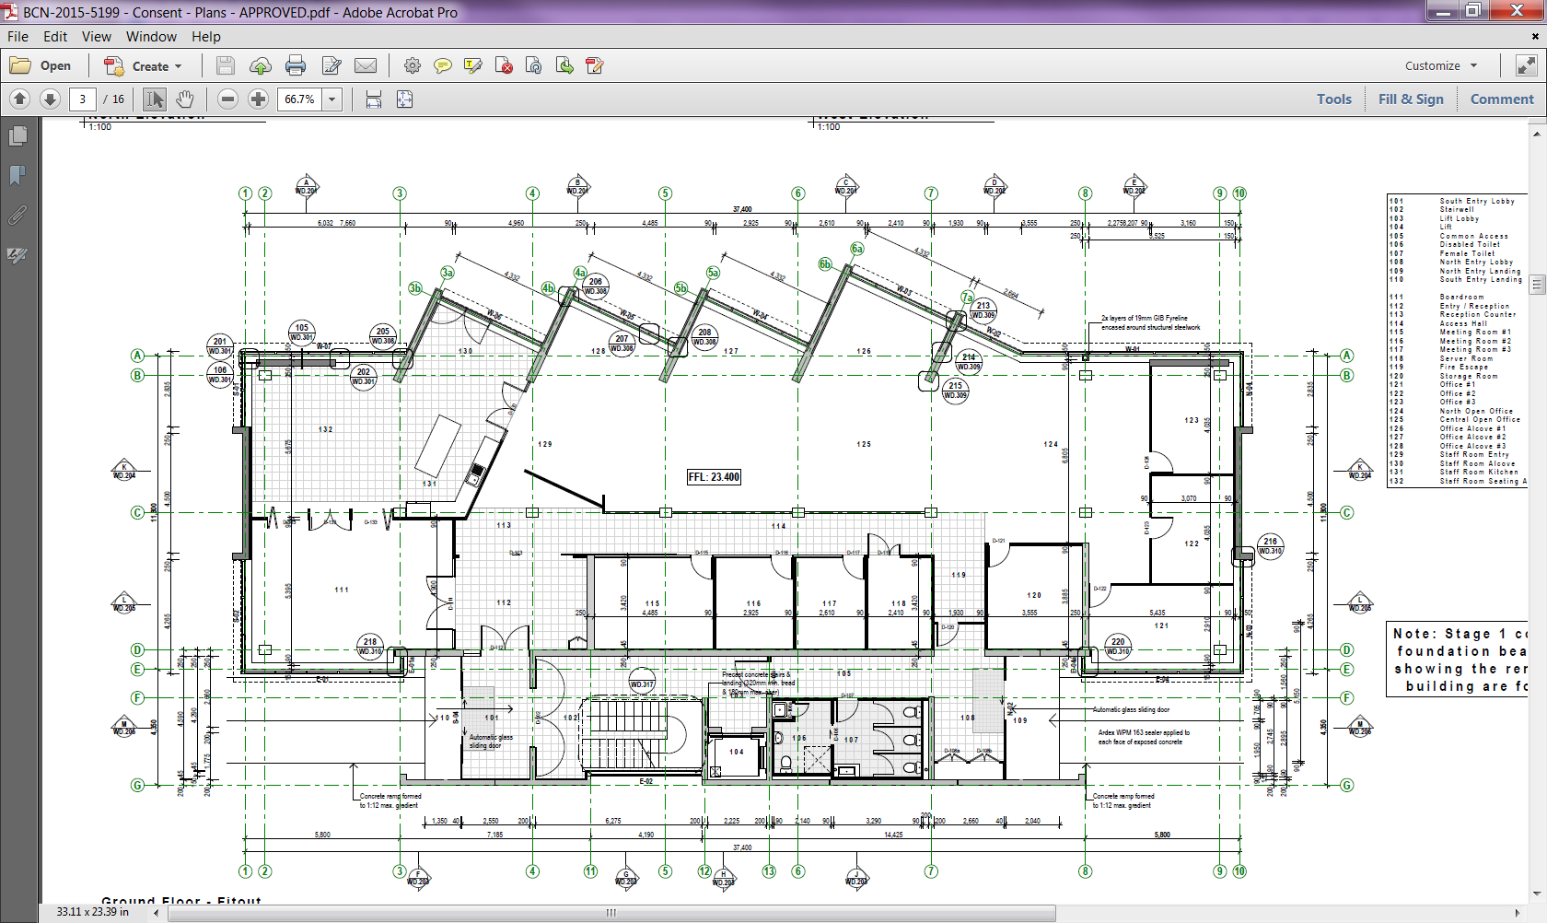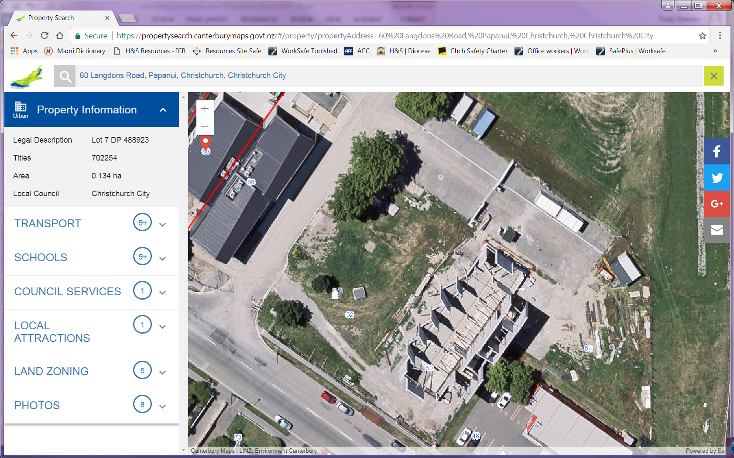

**LEGEND**

**ASSEMBLY POINT**

**EVACUATION PLAN**

**IN CASE OF FIRE**

**Your Building’s Name**

**Street Address**

**Suburb**

Tel: 00 000 0000

Exit Point

Fire Extinguisher

First Aid

Fire Alarm Pull Station

1. Remove people from danger.
2. Activate nearest fire alarm.
3. Leave building using nearest exit.
4. Do not use elevators.
5. Call 111.
6. Meet at the assembly point.
7. Listen to the Wardens!

**ADDRESS**

**You Are**

**Here**

Assembly Point