Methodist Church of New Zealand Caring for Our People
Abc Church Manaakitia ā Tātou Tāngata
Street Address, Town

INCIDENT REPORT

Name:
I had, or witnessed a:
Near Miss [nothing happened but it might/sticking plaster or less to fix]
Minor Incident [more than a sticking plaster/people had to help]
Major Incident [major first aid/doctor follow up/ambulance/hospital/
stop work/asbestos/contamination] Investigation needed Tel. 027 457 4196.
Date: Time:
Where: (be specific so others can identify the spot)
What happened:
Any action taken to stop this happening again? (who did what, and when)
Fix-it action still to be taken
Suggestions to fix it?
Thank you for helping others and taking the time to fill in this report!
Please give this to [the Parish Council]. Use other side of the page if necessary
Methodist Church of New Zealand Caring for Our People
Abc Church Manaakitia ā Tātou Tāngata
Street Address, Town

INCIDENT REPORT

Name:
I had, or witnessed a:
Near Miss [nothing happened but it might/sticking plaster or less to fix]
Minor Incident [more than a sticking plaster/people had to help]
Major Incident [major first aid/doctor follow up/ambulance/hospital/
stop work/asbestos/contamination] Investigation needed Tel. 027 457 4196.
Date: Time:
Where: (be specific so others can identify the spot)
What happened:
Any action taken to stop this happening again? (who did what, and when)
Fix-it action still to be taken
Suggestions to fix it?
Thank you for helping others and taking the time to fill in this report!
Please give this to [the Parish Council]. Use other side of the page if necessary

Office Use:
Prioritise the response needed (circle priority)
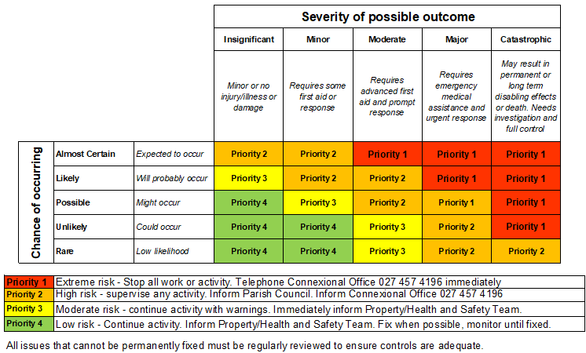
Date entered into risk register:
Person taking corrective actions:

Office Use:
Prioritise the response needed (circle priority)
Date entered into risk register:
Person taking corrective actions:

