METHODIST MISSION AND ECUMENICAL NEWSLETTER - September 2022
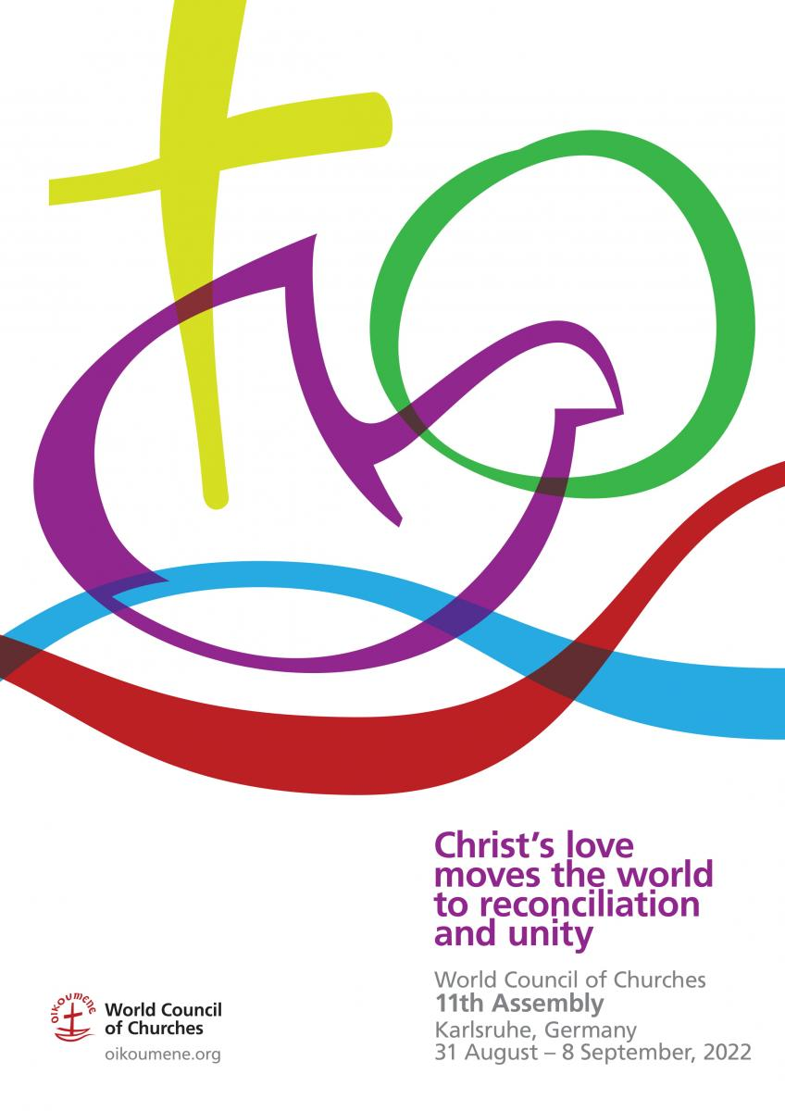
WORLD COUNCIL OF CHURCHES - 11th Assembly
The 11th Assembly of the World Council of Churches took place in Karlsruhe, Germany, from August 31 to September 8, under the theme "Christ's love moves the world to reconciliation and unity".
The WCC Assembly is the highest governing body of the World Council of Churches (WCC), and normally meets every eight years. It is the only time when the entire fellowship of member churches comes together in one place for prayer and celebration.
A WCC Assembly is a special time in the lives of member churches, ecumenical partners, and other churches, as it brings together more than 4000 participants, from all over the world. It is a unique opportunity for the churches to deepen their commitment to visible unity and common witness. This makes a WCC Assembly the most diverse Christian gathering of its size in the world.
More reporting will follow from the MCNZ repsentatives who participated in this event. In the meantime, Assembly News can be found at the links below …
Full list of articles from the Assembly: https://www.oikoumene.org/about-the-wcc/organizational-structure/assembly#documents

Particular documents of interest include:
Statement on War in Ukraine
Assembly presents minute on building peace on the Korean Peninsula
Living Planet statement on seeking a just and sustainable global community
WCC statement urges active engagement to resolve bring peace and justice to the Middle East
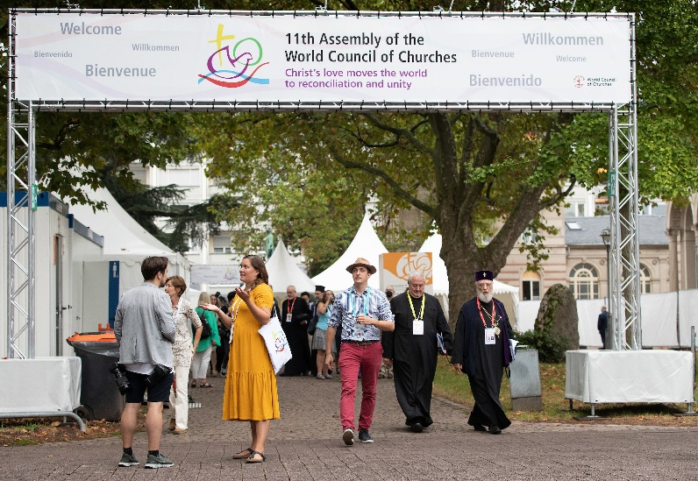

WEEK OF PRAYER FOR WORLD PEACE: an interfaith and ecumenical opportunity
The Week of Prayer for World Peace is an opportunity for people of all faiths to pray in their own gatherings or with people of other faiths for world peace. This year the Week will be observed between 16th and 23rd October.
A prayer resource has been produced by the New Zealand organising committee with prayers, readings and affirmations from many faiths to use each day. It has used the content from the prayer resource created by the Week of Prayer for World Peace multi-faith committee based in Great Britain. Religious communities and interfaith groups throughout Aotearoa-New Zealand are encouraged to celebrate the Week both in our own observances and together with people of different faiths.
You will find the prayer resource attached in multiple formats so you can choose how you will print it yourself and distribute it, and incorporate into local observances:
- Week Of Prayer 2022 - A5 6p.pdf: 6 page A5-sized version with front and back pages
- Week Of Prayer 2022 - A5 4p.pdf: page A5-sized version with just the readings for the Week
- Week Of Prayer 2022 – A4 2p.pdf: 2 page A4-sized version with just the readings for the Week which can be printed double-sided and folded
There will also be a Facebook posting of the readings each day: https://www.facebook.com/WPWPNZ2014

MISSION AND ECUMENICAL BOARD
Methodist Church of New Zealand
Te Hāhi Weteriana o Aotearoa
[Acting] Director: Rev. Tony Franklin-Ross
Postal: 20a Georgina Street, Freemans Bay, Auckland 1011
Phone: 021-481 816 (Mobile)
E-mail: mm-e@methodist.org.nz
www.methodist.org.nz/mahi/mme

