The Methodist Church of New Zealand

Te Hāhi Weteriana o Aotearoa

OFFICE BUILDING

STREET ADDRESS

TOWN

**EMERGENCY RESPONSE**

**THE FIRST PRIORITY IN AN EMERGENCY IS THE SAFETY OF ALL PEOPLE PRESENT**

* Raise the alarm.
* Turn to the relevant page to confirm what to do.

|  |  |
| --- | --- |
| **During office hours** | [Name of Office Hours Contact Person]  {phone} |
| **Chief Warden** | [Name of chief Warden] |
| **Wardens** | [Name of warden/s] |
| **First Aiders** | [Name of first aider]  [Name of first aider] |
| **After office hours** | [Name of ] (for the alarm)[Name of ]  {phone}{phone}  [Name of ][Name of ]  {phone}{phone} |
| **Report Incidents to:** | [Name of Appropriate Person]  {phone} |

**In case of a major incident phone 111**

To be effective, this chart must be read and understood by all staff until it becomes second nature!

Turn page…

Emergency Procedures Guidelines…

|  |  |
| --- | --- |
| **Key items’ locations** | Gas shut off:   * + [Clear instructions to let others find the location easily, or use “No gas on site”]   Main Fuse Box – for Ground Floor:   * + [Clear instructions to let others find the location easily and quickly]   Main water toby:   * + [Clear instructions to let others find the location easily and quickly]   Gas/oxygen cylinders:   * + [Clear instructions to let others find the location easily, or use “No cylinders on site”]   Fire Alarm panel   * + [Clear instructions to let others find the location easily, or use “No fire alarm panel on site”] |
| **Emergency Contacts**   |  | | --- | | *Remember*  *Dial 111*  *for immediate*  *Fire, Police and Ambulance requirements* | | [Name] Police Station  [Street Address, Town]  {phone}  [Name] Fire Station  [Street Address, Town]  {phone}  [Name] Medical  [Street Address, Town]  {phone}  [Name] Hospital  [Street Address, Town]  {phone}  Poisons Centre  0800 764 766 |
| **Neighbours** | [Name of neighbour]  [Street Address, Town]  {phone}  [Name of neighbour]  [Street Address, Town]  {phone} |
| **Contractors and Consultants** | Builder  [Company name – contact name]  {phone}  Cleaner  [Company name – contact name]  {phone}  Security  [Company name – contact name]  {phone}  Plumber  [Company name – contact name]  {phone}  Air Con  [Company name – contact name]  {phone}  Electrician  [Company name – contact name]  {phone} |

**POWER FAILURE**

*If a general power supply failure occurs:*

|  |  |
| --- | --- |
| **Remain calm** | Assist visitors and staff in your area  Building entry doors will [unlock automagically] |
| **If you are in an unlit area** | * Use the light on your cellphone if you have one, or, * Wait for a Warden who will move through all unlit spaces with flashlights * Wardens will escort people to safety * Remember these instructions as you will have difficulty reading them in the dark! |
| **If you are stuck in an elevator** | * Stay calm! Do you have your cell phone? * Use the emergency telephone to notify the operator * Phone the [Name of Office Hours Contact Person] if you are able   {phone number} |
| **Wait for Wardens instructions** | * Wardens will evaluate the risk at the time * If asked to evacuate, go to Assembly Area [where?] |
| **Look after people first** | * Leave the Wardens to secure the building |

**EXPLOSIONS**

*If there is an explosion*

|  |  |
| --- | --- |
| **Remain calm and alert** | * Remain calm and be prepared for more explosions * Avoid areas where objects may fall on you (eg windows, mirrors, overhead fixtures, filing cabinets, bookcases) * Be guided by Wardens or emergency services personnel |
| **If evacuation is declared** | * Be guided by Wardens or emergency services personnel * Go to the assembly point in [where?] * When evacuating, leave doors and windows open |
| **If someone is injured** | * Don’t move injured people unnecessarily * Inform your Wardens, and then follow their instructions * Reassure the person that help is on the way * Stay with them to make sure they get help * Render first aid only if you are trained to do so |
| ***Remember!*** | * *Open doors carefully* * *Watch for falling objects* * *Do not use lifts* * *Do not use matches or lighters* * *Keep telephone lines free* |
| **Be aware of possible causes** | * Bombs * Flammable/explosive objects * Chemical accidents * Leaking gas * Motor vehicles |

**EARTHQUAKE**

*If there is an earthquake:*

|  |  |
| --- | --- |
| **During** | * Take cover under your desk or workstation * If you are away from your desk, seek shelter in a secure position such as a doorway * Beware of falling objects * Stay away from windows * Remain where you are until tremors have ceased |
| **After** | * Remain where you are until risk from falling objects ceases * Make contact with others to identify the severity of the situation * Text people that weren’t on site – avoid overloading phone systems * Follow the instructions of the Wardens |
| **If someone is injured** | * Don’t move injured people unnecessarily * Inform your Wardens * Reassure the person that help is on the way * Stay with them to make sure they get help * Render first aid only if you are trained to do so |
| **Evacuation** | * Follow the instructions of the Wardens * Go the assembly point in [where?] |
| ***Remember!*** | * *Look after your own safety first* * *Life comes before property* * *Keep telephone lines free* * *Avoid ‘live’ electricity: hanging cables, light fittings, or any metal objects or water that might be in contact with loose wires* |

**DISRUPTIVE VISITORS / UNWANTED BEHAVIOUR**

*If a visitor shouldn’t be here, or their behaviour is causing concern:*

|  |  |
| --- | --- |
| **Give yourself an escape route** | * Keep moving if you have to * Don’t let them block your exit path |
| **Think body language** | * Turn side on – to be less confrontational |
| **Keep clear of them** | * Keep cool * Keep yourself or others out of harm’s way. * Keep at least 2m between you and them |
| **Keep calm** | * Breathe! |
| **Distract them so you can leave** | * Offer to fetch them tea, water, coffee * Offer to fetch them a manager to help |
| **Tell others**   |  | | --- | | *Remember!*  *Dial 111 if you can*  *or tell someone else*  *so they can!* | | * You don’t have to handle this by yourself * Use   + Email   + Text   + Buzzer   + Telephone   + Yell |
| **If they are outside** | * Physically lock building down to authorised entry only * Stay away from windows |

**BOMB THREATS AND SUSPICIOUS OBJECTS**

*If there is a telephone threat:*

|  |  |
| --- | --- |
| **Listen Carefully** | * Remain calm, be polite and show interest, try to keep the caller talking * Gather information * Refer to the bomb threat checklist (next page) |
| **Get help** | * Pass a note to get someone else to help you |
| **When the call ends** | Inform [Name of Office Hours Contact Person]  {phone}   * [Name of Office Hours Contact Person] will contact the police * Write out a bomb threat report (all the details that you can remember) * Control any panic * Inform the closest manager to deal with the situation * Evacuate the building if instructed |

*If there is a suspicious parcel or object:*

|  |  |
| --- | --- |
| **Keep away** | * Remain calm * Keep everyone away |
| **Tell Office Reception** | * Inform [Name of Office Hours Contact Person]   {phone}   * [Name of Office Hours Contact Person]will contact the police |
| **Gather information** | * Write down all details for the Police to use |
| **Keep calm** | * Control any panic * Inform the closest manager to deal with the situation * Evacuate the building if instructed |

Turn page…

**BOMB THREAT CHECKLIST**

|  |  |
| --- | --- |
| **Keep Calm**  **Don’t hang up!** | * Write down the threat * Check phone display for a phone number * Note the exact wording |
| **Ask the caller these questions** | 1. When will the bomb explode? 2. What does the bomb look like? 3. What kind of bomb is it? 4. What will make the bomb explode? 5. Did you place the bomb? 6. Where did you put the bomb? 7. Are you familiar with the area? 8. Why did you place the bomb? 9. What is your name? 10. Where are you, what is the address? |
| **Pay attention to caller’s voice** | * Accent (specify) – well spoken? * Male? Female? Age? * Any impediment (specify) – incoherent? * Voice (loud, soft) – irrational? * Speech (fast, slow) – taped? * Diction (clear, muffled) – message read by caller? * Manner (calm, emotional) – abusive? * Do you recognise the voice? * If so, who do you think it is? |
| **Note any background noises** | * Street or house noises * Aircraft / Machinery * Voices/Music * Local call/cell phone |
| **General Information** | * Date * Time * Call length * Caller display details |

**First Aid ReSponse**

*What to do if a person is ill or injured:*

|  |  |
| --- | --- |
| **Avoid moving the person** | Don’t move the person unnecessarily unless the situation is life threatening |
| **Inform the Office Reception** | * [Name of Office Hours Contact Person]will arrange first aid assistance or dial 111 |
| **Wait with the person** | * Reassure the person that help is on the way * Render first aid only if you are trained to do so |
| **Give help and information** | * Find out the person’s name * Help to take care of their needs |
| **After the person is well cared for** | * Inform the person’s manager * Ensure an incident report is completed |

*Bleeding Wounds*

|  |  |
| --- | --- |
| **Control the bleeding** | * Apply direct pressure to wound – use your hand/s (wear gloves) * Elevate (raise) the limb * Apply a pad and firm bandage * If necessary use clean rags or clothing |
| **Remember** | * Always check circulation below the bandage * If there is tingling, numbness or blues, loosen the bandage |

*Breathing difficulties*

|  |  |
| --- | --- |
| **Unconscious but breathing** | * Turn them onto their side * Clear airway of obstructions, such as tongue or vomit |
| **Remember** | * Seek medical help, if necessary |

Turn page…

First Aid Response…

*Burn Management*

|  |  |
| --- | --- |
| **Cool the burn** | * Cool under cool running water for 10-15 minutes |
| **Cover the wound** | * If necessary, cover the burn with a clean dressing or plastic wrap before removing the person to medical aid |
| **Remember** | * Leave any blisters alone * Leave stuck clothing alone * Do not apply creams |

*Eyes - Foreign bodies*

|  |  |
| --- | --- |
| **Wash the eyes** | * Wash the eye(s) with clean clear water |
| **If washing doesn’t work** | * If the foreign body is stuck to the eye surface, DO NOT attempt to remove it * Place a covering over both eyes and send for, or take the person to, medical aid |

*Poisoning*

|  |  |
| --- | --- |
| **Inform the Office Reception** | * [Name of Office Hours Contact Person]will arrange first aid assistance   {phone} |
| **Remember** | * Do not make the person vomit without advice from a medical professional * Do not give fluids without advice from a medical professional * Safety Data Sheet for the poison if it is held on site, are in [location?]. |

*Wounds - minor*

|  |  |
| --- | --- |
| **Clean the wound** | * With soap and water |
| **Cover the wound** | * Cover lightly with clean dressing |
| **Remember** | * Seek medical help if necessary |

First Aid Response…

*CPR – Cardio-pulmonary resuscitation in summary*

|  |  |
| --- | --- |
| **When to do CPR** | * Patient has collapsed * Is non-responsive * Is not breathing normally |
| **Assess carefully** | * Carefully decide what emergency care is needed * Chest compressions are the most important part of CPR * If you cannot give breaths, then DO attempt chest compressions |
| **Danger** | * Check for the safety of yourself, the casualty and bystanders |
| **Response?** | * Check for a response:   + Tap the person   + Gently shake and shout |
| **Send for help** | * Phone 111 and ask for an ambulance |
| **Airway** | * Open the airway * Tilt head back |
| **Breathing and CPR** | * If not breathing normally, start CPR   + 30 chest compressions   + Two breaths |

*CPR Trained First Aiders*

|  |  |
| --- | --- |
| **First Aiders** | * [Name of first aider] * [Name of first aider |

*Medical Centre*

|  |  |
| --- | --- |
| **Closest Emergency Centre** | * [Name of emergency medical] [street address] {phone} * Or dial 111 and ask for an ambulance |

Turn page…

First Aid Response…

*CPR – Cardio-pulmonary resuscitation in detail*

|  |  |
| --- | --- |
| **Arrange the patient’s head** | * Tilt head back * Raise chin forward * Check for normal breathing |
| **Check for normal breathing** | * Look for movement * Listen for breathing * Feel for breath on your cheek * If casualty is not breathing normally, turn on back, start CPR |
| **Chest compressions** | * Position hands centre of chest, push down firmly and quickly 30 times |
| **Poison suspected?** | * Make sure there is no residual poison in the mouth * Consider mouth to nose resuscitation |
| **Breathing** | * Tilt head * Pinch nose * Seal your mouth over patient’s mouth * Blow twice into patient’s mouth |
| **While waiting for help to arrive** | * Repeat   + 30 chest compressions   + 2 breaths |
| **Reluctant to give mouth to mouth** | * Continue with chest compressions * Chest compressions are the most important part of CPR |

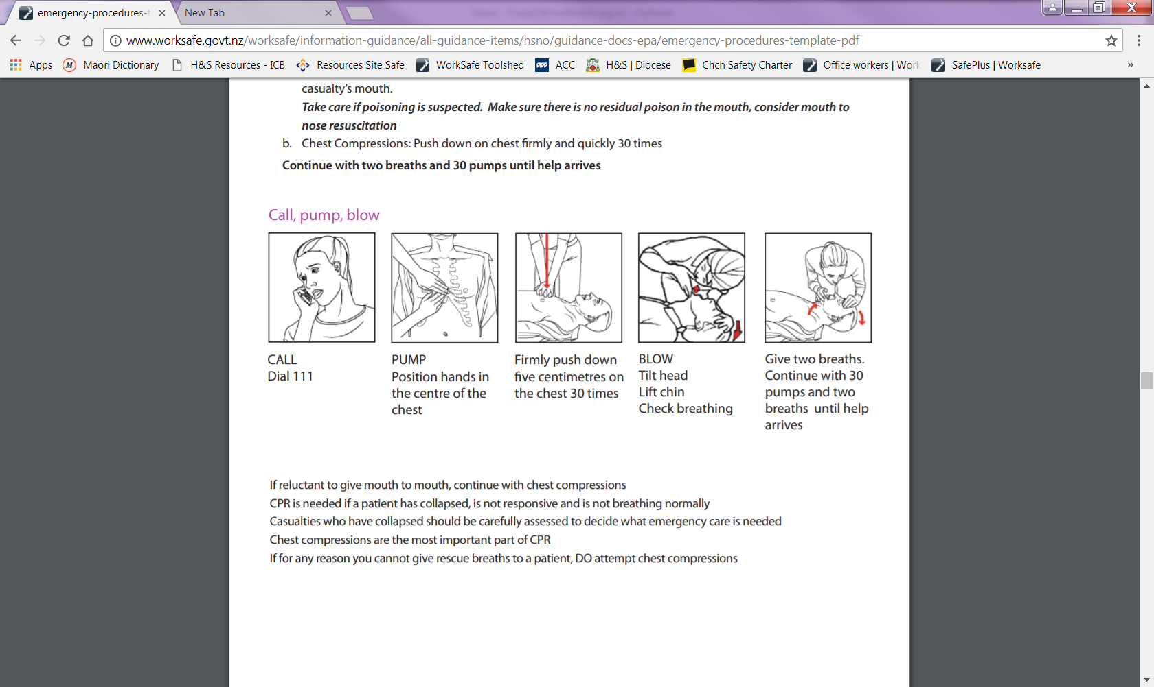

**FIRE**

*If there is a fire:*

|  |  |
| --- | --- |
| **Raise the alarm** | * Remain calm * Warn occupants in the immediate area * Activate nearest fire alarm by nearest building exit * Or commence a manual warning (whistle, shout etc) and then activate nearest fire alarm * **Ring 111** * Automatic detectors may also trigger the alarm |
| **When the alarm is raised** | * Exterior doors will unlock automagically * Evacuate the building * Help others to evacuate if required * Proceed to the Assembly Area in the [where?] |
| **Exit the building** | * Only use stairs, not the lift * Close the doors * *CLOSED DOORS INDICATE THE ROOM IS CLEAR* * Only return to the building when advised by Fire and Emergency/ Wardens |

*Useful things to know:*

|  |  |
| --- | --- |
| **Escape route** | * Know the evacuation plan! * There are [how many?] exit points. |
| **Confining fire** | * Oxygen feeds fires * Close doors, do not open windows * External Doors will open automagically |
| **Hot or smoking doors** | * Do not open hot or smoking doors * Before opening any door, touch it near the top with the back of your hand to test for heat. * If door is hot or smoke is visible, do NOT open the door |
| **Very small fire?** | * If you are trained and confident, use a fire extinguisher * Use a fire extinguisher if it is deemed safe to do so * Report the fire to the Wardens |

Turn page…

Fire…

|  |  |
| --- | --- |
| **Report all fires** | * Tell the Wardens |
| **Using a fire extinguisher** | * Always ensure your escape path is clear of fire and obstacles (change your escape path if necessary) * Make sure the extinguisher is of the correct type * Make the extinguisher ready for use by breaking the seal/removing the safety pin * Carry the extinguisher to the fire * Keep yourself low to reduce the effect of heat and smoke * When in position, aim the extinguisher in a sweeping motion across the base of the flames * Keep going until you have completely extinguished the fire * If the fire becomes uncontrollable, or there is too much heat or smoke for safety, LEAVE IMMEDIATELY |
| **After the event** | * Complete an incident report * Review the effectiveness of the emergency plan |

Fire…

**[Address] – Ground Floor Fire Alarms and Fire Extinguishers**

3 x Fire Alarms by all exits

3 x Extinguishers (Staff Room, reception, server room)

1 x First Aid Kit (Staff Room

**Carpark**

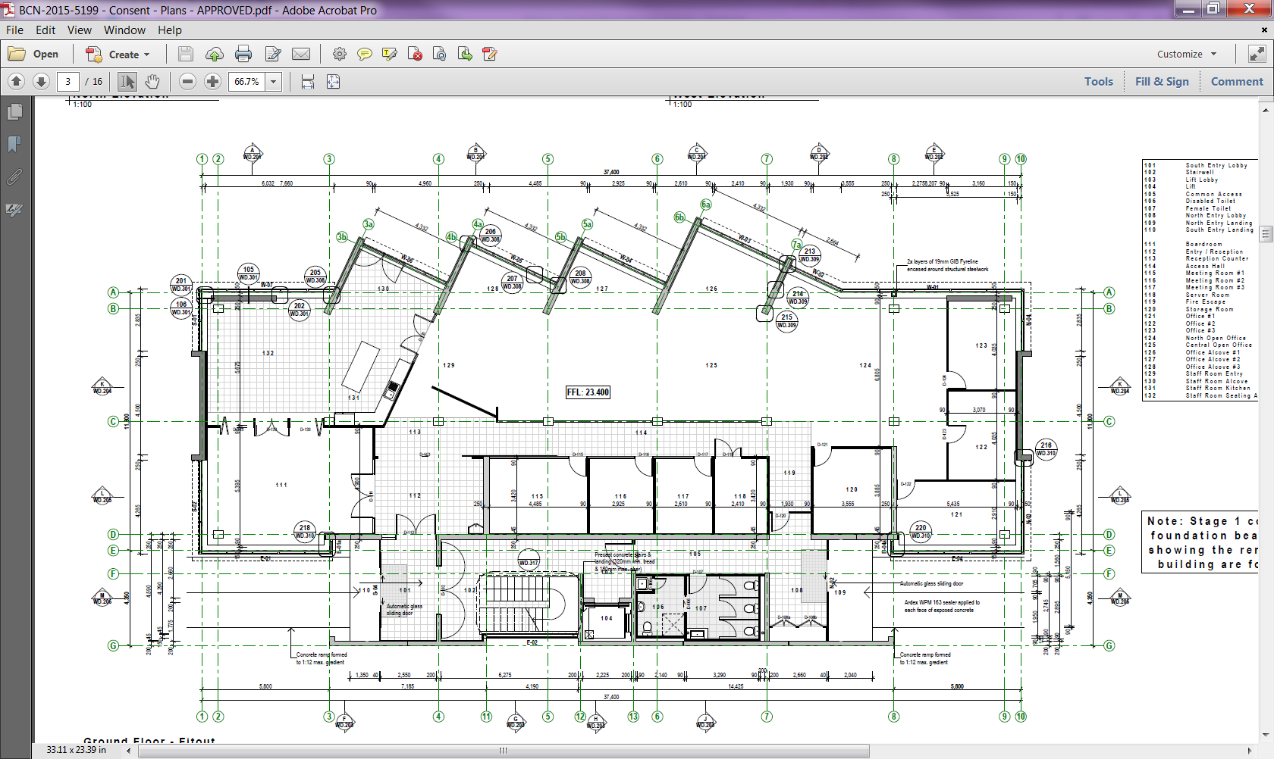

**Langdons Road**

**Ext** - Extinguishers

**F** - Fire Alarm

**+** - First Aid Kit

**AED** - Defibrillator

**+**

**F**

**Ext**

**Ext**

**Ext**

**F**

**F**

**Evacuation**

*If the event of an evacuation*

|  |  |
| --- | --- |
| **Be prepared** | * Recognise the sound of the evacuation alarm * Know at least two ways out of the building from your regular workspace * Know where your nearest fire alarm and exit are * Tell Office Reception if you require evacuation assistance. A “Personal Emergency Evacuation Plan” will be agreed |
| **Know the alarm sound** | * Is a continuously ringing bell, a continuous warning siren etc. throughout the building on both floors * The voice also tells you to evacuate! |
| **When you hear the evacuation alarm** | * Remain calm * Be hands free and distraction free when you exit the building   + Phones and keys in your pockets   + handbag closed (avoid spillages) and securely hooked on your shoulder (handsfree!)   + Leave food and drink behind * Leave quickly through the closest-safest exit of the building * Listen to the wardens |
| **Escape routes** | * Ground Floor   + [name them all] * First Floor   + Use the stairs ONLY, and then the [which exit?] |
| **After hours** | * Wardens may not be present * Warn occupants in the immediate area * Activate the nearest fire alarm * You must call 111 * Evacuate the building, proceed to assembly area * You must liaise with emergency response services when they arrive on site |
| **Instances beyond the normal arrangements** | * Such as working alone, late openings, events * Consult with the [office management team] to keep safe * Create an after hours evacuation plan |

Turn page…

Evacuation Plan…

**[Address] – Assembly Point**

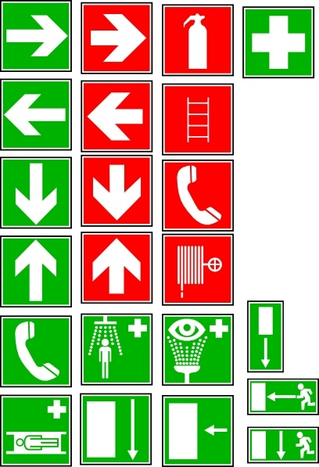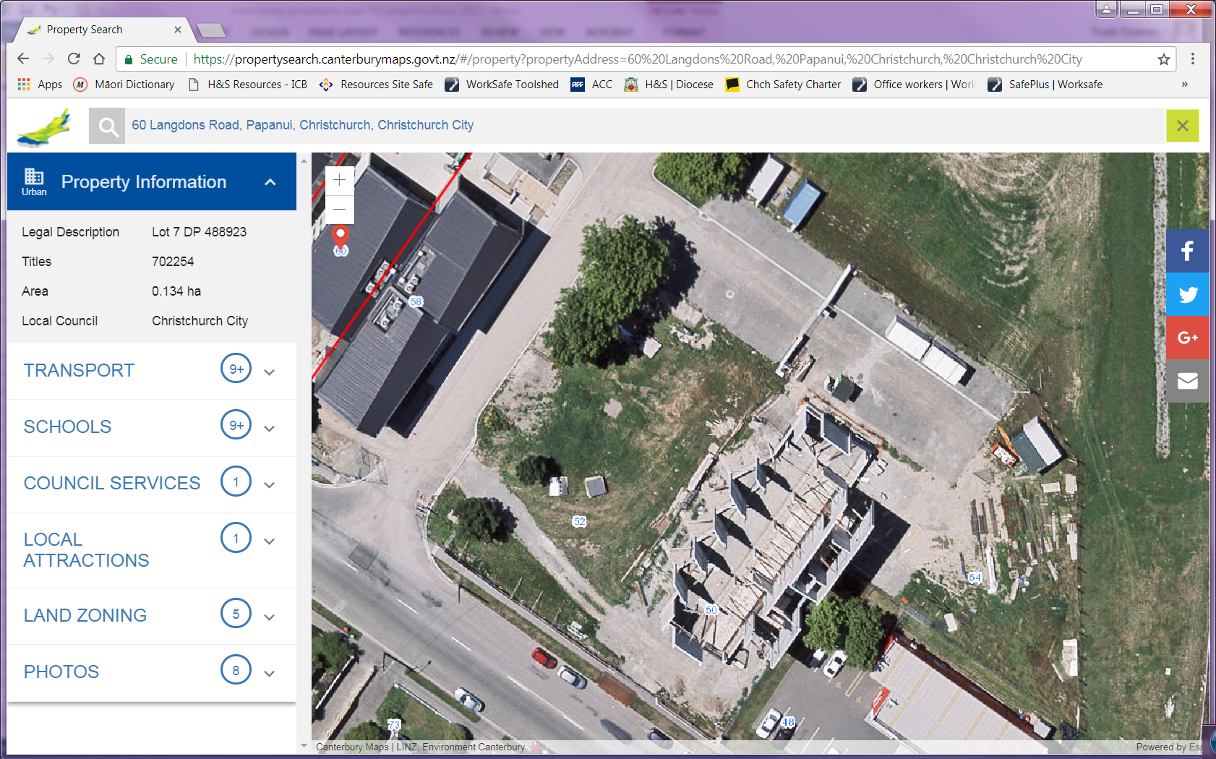

Assembly Point

Evacuation Plan…

|  |  |
| --- | --- |
| **As you are leaving** | * Check that others in the building are also leaving, including visitors and volunteers * Exit with your hands free of “stuff”. * You may take your car keys and purse * Do not take large or heavy objects * Assist anyone who may be in need of calm direction, or physical assistance * Shut all doors behind you as you go (closed doors slow the spread of fire, smoke and water) * Proceed as quickly as possible in an orderly manner, without pushing or shoving * Hold handrails when you are walking if you are on stairs |
| **Doors** | * Fire Evacuation   + Shut the internal doors – deprive the fire of air   + External doors will open upon alarm activation * Explosion Evacuation   + Leave the doors (and windows if any) open! * Exterior doors will fully open on power failure/fire alarm * Fire doors will release and shut on power failure/fire alarm – manually push/pull them to open * Doors will resume normal function after power is restored or the fire alarm is shut off |
| **Know the Assembly Point** | * [where?] for all occupants of the building |
| **Once out of the building** | * Move away from the structure * Proceed to the Assembly Area in the [where?] * Meet and remain in the Assembly Area in the [where?] * Be patient while noses are counted * Wait for further instructions from the Wardens |
| **Obey the Wardens** | * The Warden present in each area is responsible for ensuring everyone in their area evacuates * Please assist by following the Warden’s instructions |

Turn page…

Evacuation Plan…

**[Address] – Assembly Point**

****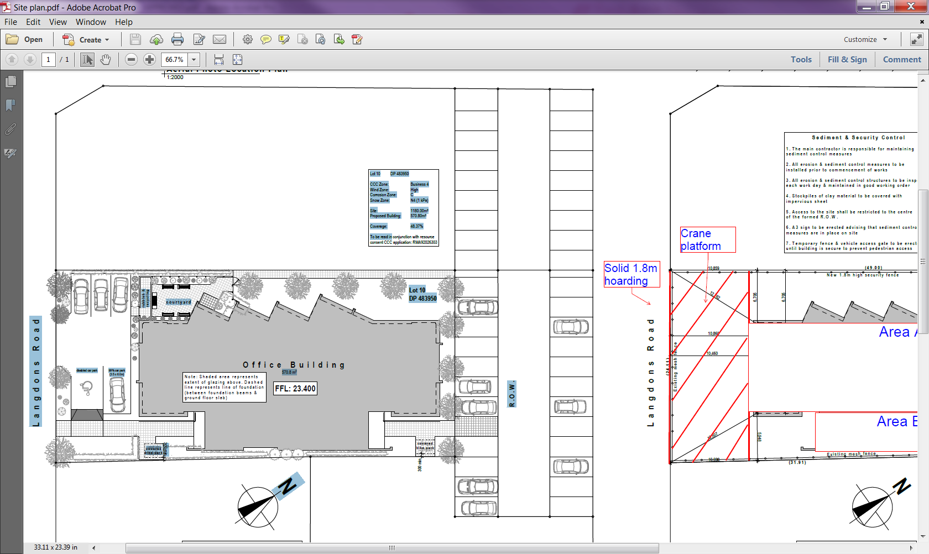

Assembly Point

Evacuation Plan…

**[Address] – Ground Floor Services**



**E** – Electrical board

**BBQ** – 9kg BBQ cylinder

**CO2** – Fizzy water

**F**– Fire board

**H2O** – Water toby

**H2O**

Green box front LHS (face building) of carpark

**BBQ**

Shed in fenced courtyard

**CO2**

**F**

**E**

**Wardens**

*A summary of tasks for the building wardens*

|  |  |
| --- | --- |
| **Wardens** | Chief Warden  **[name]**  Warden 1  **[name]**  Warden 2  **[name]** |
| **Equipment** | * Identification vests * Flashlight (with vests and one on utilities bench) * Instructions with vests * Mobile phones * Personal Emergency Evacuation Plans |
| **Qualification** | * [Normally in the building between 8.30am and 5pm Mon-Fri.] * Arrange a back up arrangement for prolonged absence. * [Attend building warden course.] |
| **Power failure** | **Warden 1**   * Escort people to safety from the unlit areas (toilets, stairwells) * Co-ordinate with Office Receptionthat everyone is accounted for * Evaluate/evacuate if the building is deemed unsafe in conjunction with office management team (heat, cold, light, access) * External doors will open automagically * Secure the building – Phone [security firm}, {phone} |
| **Explosions** | * You will be the contact point should someone be injured * Co-ordinate with the first aider if there are injured persons * Evaluate the building risk * Evacuate the building if outside is safer than inside * Co-ordinate with Office Receptionthat everyone is accounted for |
| **Earthquake** | * Evaluate the risk * Evacuate the building if necessary |

Turn page…

Wardens…

|  |  |
| --- | --- |
| **Evacuations** | * Put on your Warden identification * Evacuate people where you can – tell the Chief Warden where you can’t evacuate people * Sweep designated areas to ensure people are clear of the rooms – *if it is safe to do so.* * Appoint other people to help those that need assistance   **Chief Warden:**   * + Sweep [name the sweep areas]   + Co-ordinate with Office Receptionthat all staff and visitors are accounted for   + Ensure 111 has been rung (by ringing them anyway)   + Proceed to assembly area   + Await reports from other wardens   + Liaise with Fire and Emergency upon their arrival. Tell them the status of the evacuation (i.e. all out or the location of anyone remaining inside) and any other relevant information   + Ensure everyone stays outside until Fire and Emergency give the all clear.   **Warden 1:**   * + Sweep [name the sweep areas]   + Turn off power if it is safe to do so.   + Sweep Ground floor toilets   + Proceed to assembly area   + Confirm [location/s] clearance with Chief Warden   + Wait street front for emergency response and direct them to Chief Warden   **Warden 2:**   * + Sweep [name the sweep areas].   + Proceed to assembly area   + Confirm [location/s] clearance with Chief Warden   + Help keep people at the assembly area until Chief Warden gives the all clear. |
| **Absences** | * Chief Warden – Warden 1, then Warden 2 becomes chief * Wardens 1+2 – tell the Chief Warden, deputise/induct a team mate (show them the ropes) |

Wardens…

**Wardens sweep areas**

**\*\***

**Building Warden**

Alarm Panel

**Warden 2**

Ground floor

**Warden 1**

First floor/toilets

**Chief Warden**

Ground floor

Turn page…

**Office Reception**

*A summary of tasks for the receptionist*

|  |  |
| --- | --- |
| **Equipment** | * Staff list * Reception’s [sign in book] – unless App is on your phone * Telephone (cordless/mobile) |
| **During office hours** | * You are the central contact person * Staff and visitors should inform you if they know they will require evacuation assistance so that a Personal Emergency Evacuation Plan can be agreed. |
| **Plant room** | * Inform Warden 2 of scheduled work carried out in plant room. * Warden 2 needs to know this if there is an evacuation |
| **Illness and injury** | * Get the first aider to the ill/injured person * Call 111 or Poisons Centre as applicable * If required, help co-ordinate the 111 response |
| **Power Failure** | * Co-ordinate with Wardens that everyone is accounted for * Anyone stuck in the elevator may call you |
| **Disruptive visitors** | * Tell someone! * Email, text, telephone, buzz the buzzer! * Safety in numbers – get backup! * Leave the area and go find other people |
| **Dialling 111** | * Call from a safe place * Use a cordless or mobile phone * Give your   + Your name   + Name of the building – **[Name]**   + Building address – **[Street adress, and town]**   + Contact number – **{phone} *and appropriate mobile number***   + Details of emergency – ***if known*** * Do not hang up until told to do so * Ensure someone directs emergency services to the scene |
| **Bomb Threats and Suspicious Objects** | * Contact the police |

Office Reception…

|  |  |
| --- | --- |
| **Evacuations** | * Grab the [sign in book] or ensure the app is on your phone and evacuate the building with everyone else * Ensure 111 has been called. * Co-ordinate with Wardens that all staff and visitors are accounted for |
| **Reporting** | * Report all incidents to the [appropriate person] |

**First Aiders**

*A summary of tasks for the First Aiders*

|  |  |
| --- | --- |
| **Equipment** | * First Aid Kit |
| **Qualification** | * Normally in the building between 8.30am and 5pm Mon-Fri. * Arrange a back up arrangement for prolonged staff absence. * Holder of a current, approved, first aid certificate |
| **First Aiders** | **[name of first aider] –** *certified until [date]*  **[name fo first aider] –** *certified until [date]* |
| **Illness and injury** | * You will be in charge unless/until 111 response is present |
| **Poisons** | * Call the Poisons Centre, 0800 764 766 |
| **Explosions / Earthquakes / Fire** | * Co-ordinate with Wardens if there are injured people |
| **111 services** | * Coordinate with Reception and Wardens - someone to direct 111 services to the injured person |

**Emergency Plan Management**

|  |  |
| --- | --- |
| **Author** | Health and Safety Coordinator |
| **Emergency response team** | Agreed at staff meetings |
| **Back up staffing** | Raised by person going on leave  Agreed at staff meetings |
| **Training staff on the plans** | [name of appropriate person] |
| **Plan Dates** | Draft written [date]  Out to review [next date]  Approved [date approved] |
| **Review schedule** | 6 monthly |